1. Explain using your own words and including a theoretical example of each the following types of indexes:

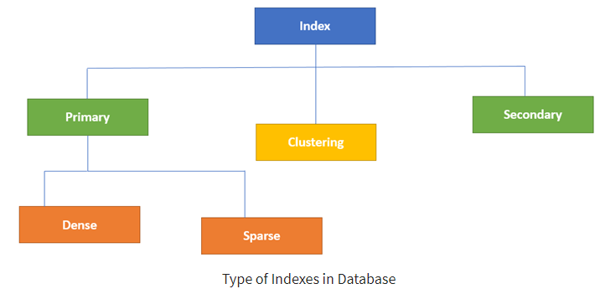

<https://www.guru99.com/indexing-in-database.html>

* Primary



The primary index is an index which contains two field, which are a primary key and the other is pointer to a date file. In the pointer field, an address is stored of the block you are looking for. A characteristic of the primary key is that it is an ordered list.



* Secondary

Secondary index contains non-ordering data. It has two fields key and non-key. There is the same number of entries in data file as there is in the index file. The index file will always be sorted, while the data file is unsorted.

* Dense

This is a one of the subsets of primary indexes meaning primary indexes can further be broken down/categorized in a dense index. In a dense index, for every record in the data, one entry is created in the index file.

* Sparse

This is a one of the subsets of primary indexes meaning primary indexes can further be broken down/categorized in a sparse index. In a sparse index, for each block of the data, one entry is created in the index file.

* Clustering

The clustering index is an ordered file and it also has two fields, which are non-key (not unique) and the other one is a pointer. This cluster index can both be primary index or secondary index. Clustering index is helpful if you want to go through the data record fast.

3.

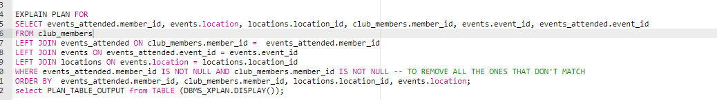

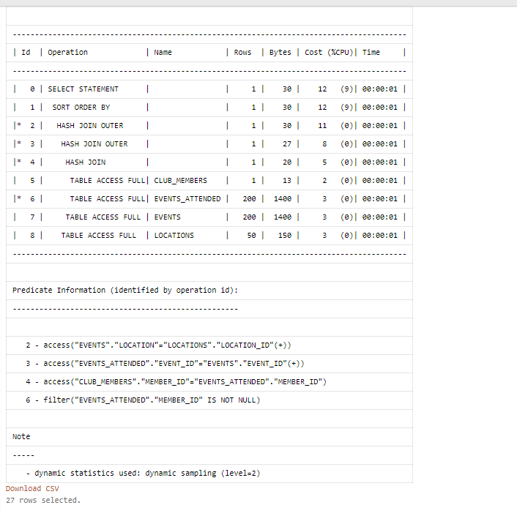

5.

